AURORA HOLIDAY RESORT
Switzerland
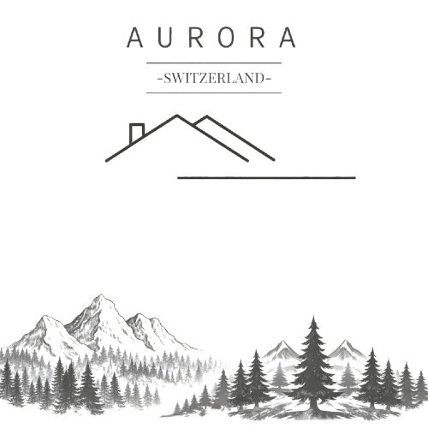

Represented By:
- Eshal Kashif // 2025-GA-52
- Ayesha Abid Bajwa // 2025-GA-17
- Muhammad Arsal // 2025-GA-55
- Mayeda Qamar // 2025-GA-05
- Hannan Ahmed Wattoo // 2025-GA- 13

Table of Contents
1. Introduction 3
2. Vision and Objective 3
3. Location Description 3
4. Our Resort Network in Switzerland 4
4. Facilities and Services 5
5. Holiday Packages 5
5.1 Matterhorn Signature Escape 6
5.2 Ultra-Luxury Alpine Experience 6
5.3 Honeymoon in the Clouds 7
5.4 Matterhorn Star Gala Package (New) 7
5.5 Swiss Heritage Rail Journey (New) 8
5.6 Bookings Summery (MS Excel) 8
6.Package Cost and Booking Management (MS Excel) 9
7. Why Choose Aurora Holiday Resort 10
8. Conclusion 10
9. Contact Information 10
10.Appendix 11
Appendix A: Excel Sheet – Total Cost Calculations 11
Appendix B: Official Website Reference 12
www.auroraholidayresort.com 12
11.Glimpse of our elegant website (Complementary) 13

1. Introduction
Aurora Holiday Resort is a luxury mountain holiday resort located in the scenic regions of Switzerland. Surrounded by snow-covered peaks, emerald valleys, and serene natural landscapes, the resort offers an ideal escape for tourists seeking peace, comfort, and elegance. The resort is designed to serve families, honeymoon couples, and high-end travelers by providing premium hospitality and unforgettable experiences.

2. Vision and Objective
The vision of Aurora Holiday Resort is to become a leading luxury holiday destination in Switzerland. The resort aims to promote tourism by offering world-class accommodation, exclusive holiday packages, and exceptional customer service while maintaining environmental sustainability and harmony with nature.

3. Location Description
Aurora Holiday Resort is situated in the Swiss Alpine region near Zermatt, one of the most iconic mountain destinations in the world. The location is renowned for the Matterhorn, fresh alpine air, and breathtaking views. It is ideal for winter sports, luxury tourism, cultural exploration, and year-round vacations, attracting both local and international visitors.

4. Our Resort Network in Switzerland
Aurora Holiday Resort operates a premium network of holiday resorts across Switzerland, each located in scenic alpine regions. These resorts are designed to offer unique mountain experiences while maintaining the same standards of luxury, comfort, and hospitality. Guests can choose from multiple resort locations based on their travel preferences and seasonal activities.

- Emer land Valley Resort(Zermatt) – A peaceful alpine retreat surrounded by green valleys
- Alpine Crest Resort(St. Mortiz) – Located at higher elevations for adventure seekers
- Silver Crest Resort(Lucerne) – Known for elegance, serenity, and premium services
- Aurora Grindelwald (Grindelwald) – A flagship resort located near the iconic Grindelwald region

All resorts operate under the Aurora brand, ensuring consistent quality, service excellence, and unforgettable mountain holiday experiences.

4. Facilities and Services
Aurora Holiday Resort offers modern and premium facilities to ensure maximum comfort for guests:

- Luxury mountain-view suites
- Central heating system
- Free high-speed Wi-Fi
- Fine-dining restaurant with Swiss and international cuisine
- Spa, sauna, and wellness center
- Infinity heated pool
- Conference and meeting halls
- 24/7 room service
- Secure parking and electric transfers

5. Holiday Packages
Aurora Holiday Resort provides exclusive luxury packages inspired by Zermatt and the Emerald Valley.

5.1 Matterhorn Signature Escape
Price: CHF 1,650 per night
Package Includes:
- Spacious Matterhorn-facing luxury suite
- Daily gourmet breakfast and fine-dining dinner
- Private guided glacier and alpine trail walk
- Full access to heated infinity pool, sauna, and steam spa
- Electric luxury transfer from Zermatt train station
- Events & Trips Included:
- Sunrise trip on the Gornergrat Railway
- Traditional Swiss alpine fondue evening
- Seasonal Zermatt cultural evening.

5.2 Ultra-Luxury Alpine Experience
Price: CHF 3,100 per night
Package Includes:
- Private luxury chalet with panoramic views
- Dedicated butler and personal assistant
- Helicopter tour around the Matterhorn
- Private chef offering Swiss-French gourmet cuisine
- Couples spa ritual with hot-stone therapy
- Chauffeur-driven electric mobility within Zermatt
- Events & Trips Included:
- VIP access to Zermatt winter galas
- Private mountain dining experience
- Exclusive ski lounge evenings

5.3 Honeymoon in the Clouds
Price: CHF 2,450 per night
Package Includes:
- Panoramic junior suite with private balcony
- Candlelight dinner with premium wine pairing
- Outdoor private jacuzzi with mountain views
- Couples massage and spa therapy
- Professional photoshoot with Matterhorn backdrop
- Champagne welcome and late checkout
- Events & Trips Included:
- Sunset snowshoe walk (winter) or alpine picnic (summer)
- Romantic mountain cinema night

5.4 Matterhorn Star Gala Package (New)
Price: CHF 2,850 per night
Package Includes:
- Invitation to an exclusive mountain gala
- Live classical or jazz music under the stars
- Champagne reception and gourmet tasting menu
- Night photography session with professional guide
- Premium suite accommodation

5.5 Swiss Heritage Rail Journey (New)
Price: CHF 2,600 per night
Package Includes:
- Glacier Express luxury panoramic carriage
(premium)
- Reserved first-class seating
(select yourself)

- Onboard Swiss wine and cheese tasting
- Guided stopovers at historic alpine villages
(including transport)
- Return transfers with concierge coordination

5.6 Bookings Summery (MS Excel)
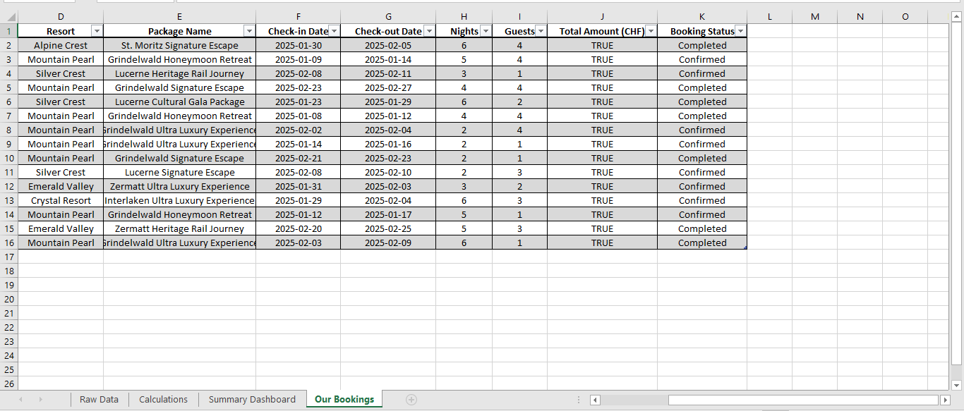

6.Package Cost and Booking Management (MS Excel)
Microsoft Excel was used to manage holiday package pricing, booking records, and cost calculations for Aurora Holiday Resort. Excel formulas were applied to ensure accuracy in total cost calculation and booking management. This helped in organizing customer data and analyzing resort operations efficiently.
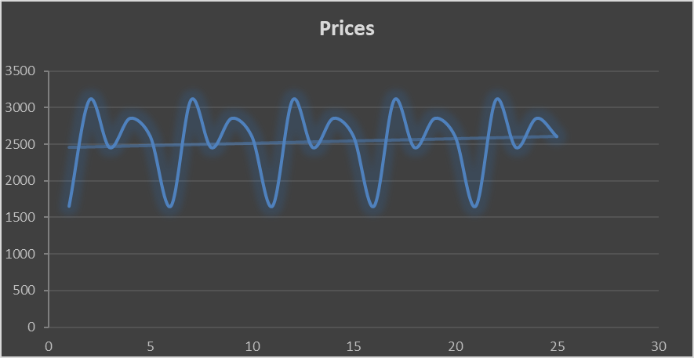
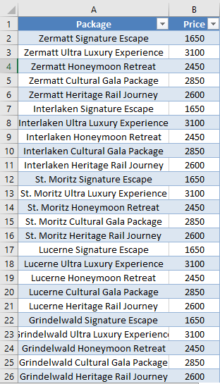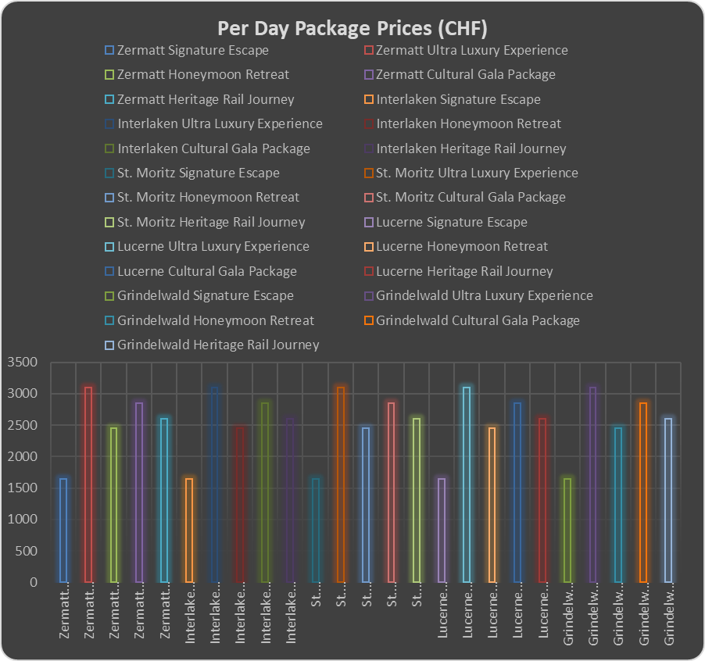

7. Why Choose Aurora Holiday Resort

- Prime mountain location near the Matterhorn
- Luxury services and premium facilities
- Personalized guest experience
- Suitable for all seasons
- High standards of comfort and hospitality

8. Conclusion
Aurora Holiday Resort represents the perfect blend of luxury, nature, and elegance. With its breathtaking alpine location, exclusive packages, and professional services, the resort offers a memorable holiday experience for travelers seeking relaxation, romance, or premium mountain adventures in Switzerland.

9. Contact Information
- Resort Name: Aurora Holiday Resort
- Location: Switzerland
- Email: aurroraresort@gmail.com
- Contact Number: +41 000 000 000

10.Appendix

Appendix A: Excel Sheet – Total Cost Calculations
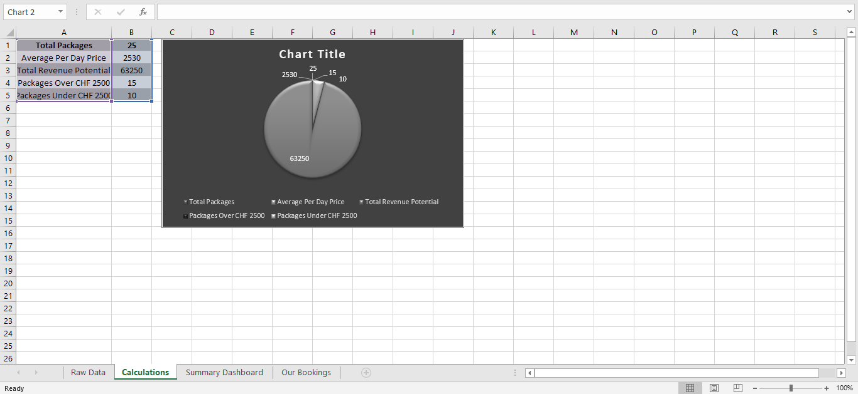
Table A1: Holiday Package Total Cost Calculations (Source: MS Excel)

This Excel worksheet demonstrates the total cost calculations for Aurora Holiday Resort’s holiday packages. Using built-in formulas, it accurately computes package pricing based on factors like duration and selected amenities. This system ensures transparent billing and efficient booking management.
The tool helps the resort maintain financial accuracy and supports decision-making for pricing strategies

Appendix B: Official Website Reference
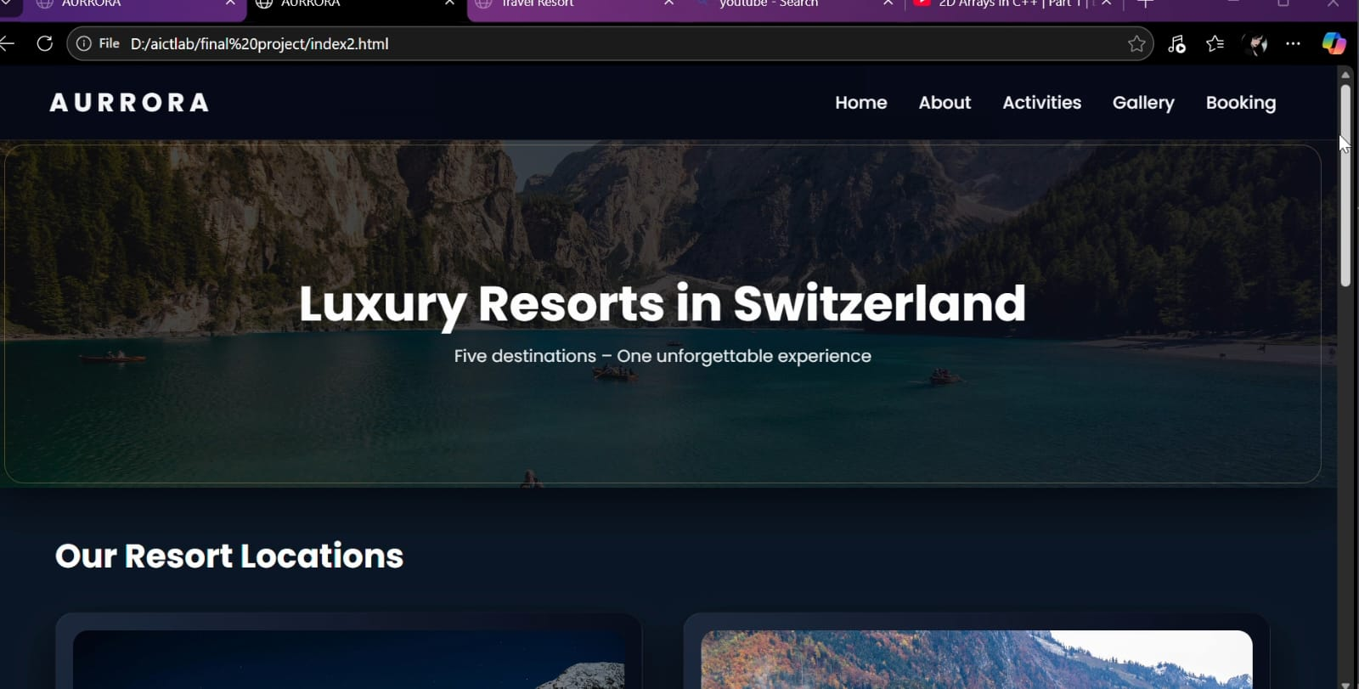
Figure B1: Official Website of Aurora Holiday Resort

The official website serves as a digital platform showcasing the resort’s brand, multiple locations, and exclusive holiday packages. It provides guests with essential information and facilitates online marketing efforts, complementing the services detailed in this report.
For more information and bookings, please visit our official website:

https://ashubaj.github.io/aurrora/
Explore our resort network, packages, activities, and gallery online

11.Glimpse of our elegant website (Complementary)
- Take a quick look at some of the exciting activities and stunning views at Aurora Holiday Resort.
Website Activities Page
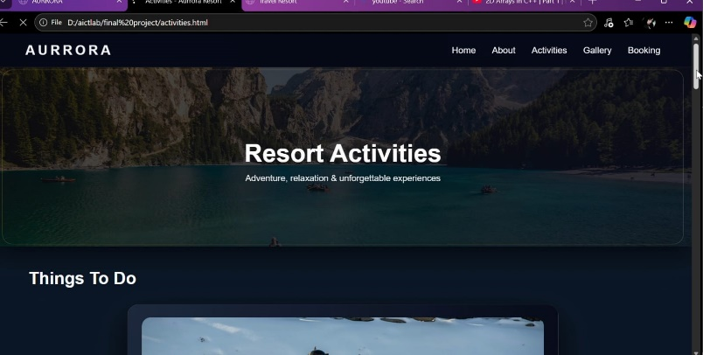
Figure B1: Activities section showcasing outdoor adventures and wellness programs at Aurora Holiday Resort.
Website Gallery Page
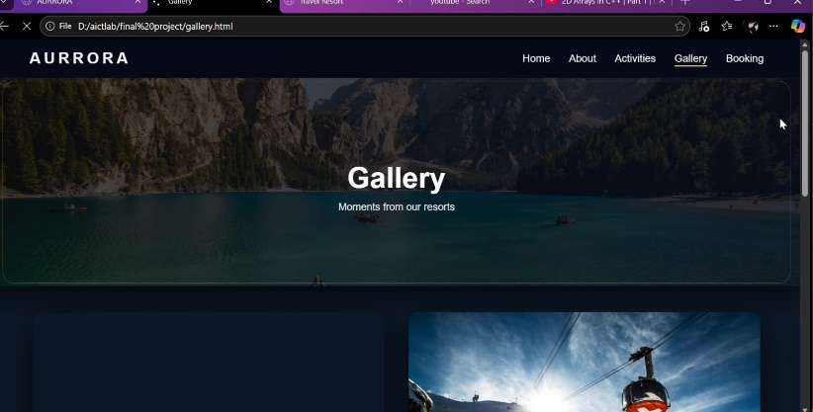
Figure B2: Gallery highlighting stunning mountain views and resort amenities

Discover the magic of Aurora Holiday Resort through
these moments— where every stay is a story waiting to be told.

